
Kaunas University of Technology
Faculty of Informatics
Laboratory work No. 4
Report of Laboratory work
P160B013 Algorithms for Big Data Processing

The report was prepared by
Kristupas Paulauskas
The laboratory work was supervised by
dr. Audrius Nečiūnas

Content
1. Introduction 3
2. Task Description 4
3. Methodology 5
3.1 Data Collection 5
3.2 K-Means Algorithm (Task 2) 5
3.3 KNN Algorithm (Task 3) 6
4. Results 7
4.1 Visualization Overview 7
4.2 Elbow Analysis (top-left panel) 7
4.3 KNN Distance Distribution (top-right panel) 8
4.4 Pairwise Distance Heatmap (middle panel) 8
4.5 Top-5 Similar Pairs with Colour Swatches (bottom panel) 8
4.6 Discussion 9
4.7 Color Palette Extraction 9
4.8 Elbow Analysis 9
4.9 KNN Similarity Search 9
5. Conclusions 10

1. Introduction
This laboratory work focuses on automated image collection, dominant color analysis using clustering algorithms, and similarity-based search in image datasets. The data consists of images of cultural and historical places of interest from three major cities: Tokyo, New York, and Paris. The goal is to extract meaningful color features from these images and use them to find visually similar places across different cities.
The work is divided into two main tasks: Task 2 implements the K-Means clustering algorithm from scratch to extract a dominant color palette from each image and encode it as a feature vector. Task 3 implements the K-Nearest Neighbors (KNN) algorithm from scratch to find the most color-similar places for any given query place.

2. Task Description
Task 1. Automatically collect images about the places of interest of the specified cities (see individual task from Lab 2 & Lab 3).
Task 2. Apply the K-Means algorithm for extraction of dominant colors. Sort the clusters based on the number of assigned points in decreasing order. Format the feature vector of K×3 numerical values, where positions 1-3 represent the centroid of the largest cluster (RGB) and the last 3 positions represent the centroid of the smallest cluster (RGB).
Task 3. Apply similar places search by formatted vectors (Task 2) using KNN.

3. Methodology

3.1 Data Collection
Image URLs for 75 places of interest (25 per city) were retrieved from Wikidata using SPARQL queries. Each record contains the place name, city, and a Wikimedia Commons image URL. The records are stored in a local SQLite database (rawdata.sqlite).
Images are downloaded using the direct Wikimedia CDN URL, constructed from the MD5 hash of the filename:
upload.wikimedia.org/wikipedia/commons/{md5[0]}/{md5[:2]}/{filename}
This approach bypasses the commons.wikimedia.org redirect server, which imposes aggressive rate limits (HTTP 429) after approximately 26 sequential requests. Downloaded images are cached locally as PNG files in the images/ folder so that subsequent runs load from disk without any network requests.

3.2 K-Means Algorithm (Task 2)
K-Means is an unsupervised clustering algorithm that partitions N data points into K clusters by minimizing the within-cluster sum of squared distances. Applied to image pixels, each cluster centroid represents a dominant color in the image.
Algorithm steps:
- Step 1 - Initialization. Select K initial centroids from the pixel set.
- Step 2 - Assignment. Each pixel is assigned to the nearest centroid using Euclidean distance: d(a, b) = √Σ(aᵢ − bᵢ)².
- Step 3 - Update. Each centroid is recomputed as the mean (R, G, B) of all pixels assigned to it.
- Step 4 - Convergence check. Two stopping conditions are available: (a) exact equality - stop when no centroid moves at all; (b) tolerance-based - stop when every centroid moves less than a threshold (default 1.0 pixel unit). Steps 2-4 repeat until convergence or until MAX_ITERATIONS (default 20) is reached.
- Step 5 - Sort by cluster size. After convergence, the number of pixels belonging to each cluster is counted. Clusters are sorted in descending order by pixel count so that the largest cluster always appears first.
- Step 6 - Build feature vector. The sorted centroids are flattened into a 1-D vector of length K×3: [R₁, G₁, B₁, R₂, G₂, B₂, …, Rₖ, Gₖ, Bₖ]. Positions 0-2 correspond to the largest cluster; positions −3… correspond to the smallest cluster.

Settings used: K = 5 colors, image resized to 150 × 150 pixels before clustering, MAX_ITERATIONS = 20, CONVERGENCE_TOLERANCE = 1.0.

3.3 KNN Algorithm (Task 3)
K-Nearest Neighbors (KNN) is a non-parametric similarity search method. Given a query item and a dataset of items with pre-computed feature vectors, KNN returns the K items whose feature vectors are closest (by Euclidean distance) to the query vector.
Algorithm steps:
- Step 1. For the query place, retrieve its K×3 feature vector.
- Step 2. Compute the Euclidean distance between the query vector and every other place's feature vector.
- Step 3. Sort all candidates in ascending order of distance.
- Step 4. Return the top K candidates. A smaller distance indicates a more similar dominant color palette.
Because the feature vectors encode color clusters sorted by size, the distance measure naturally penalizes differences in the dominant color (positions 0-2) more heavily than differences in minor colors.

4. Results

4.1 Visualization Overview
The visualization cell produces a single figure with four panels (saved as task3_visualization.png) that together summarize both the K-Means clustering quality and the KNN similarity search findings.

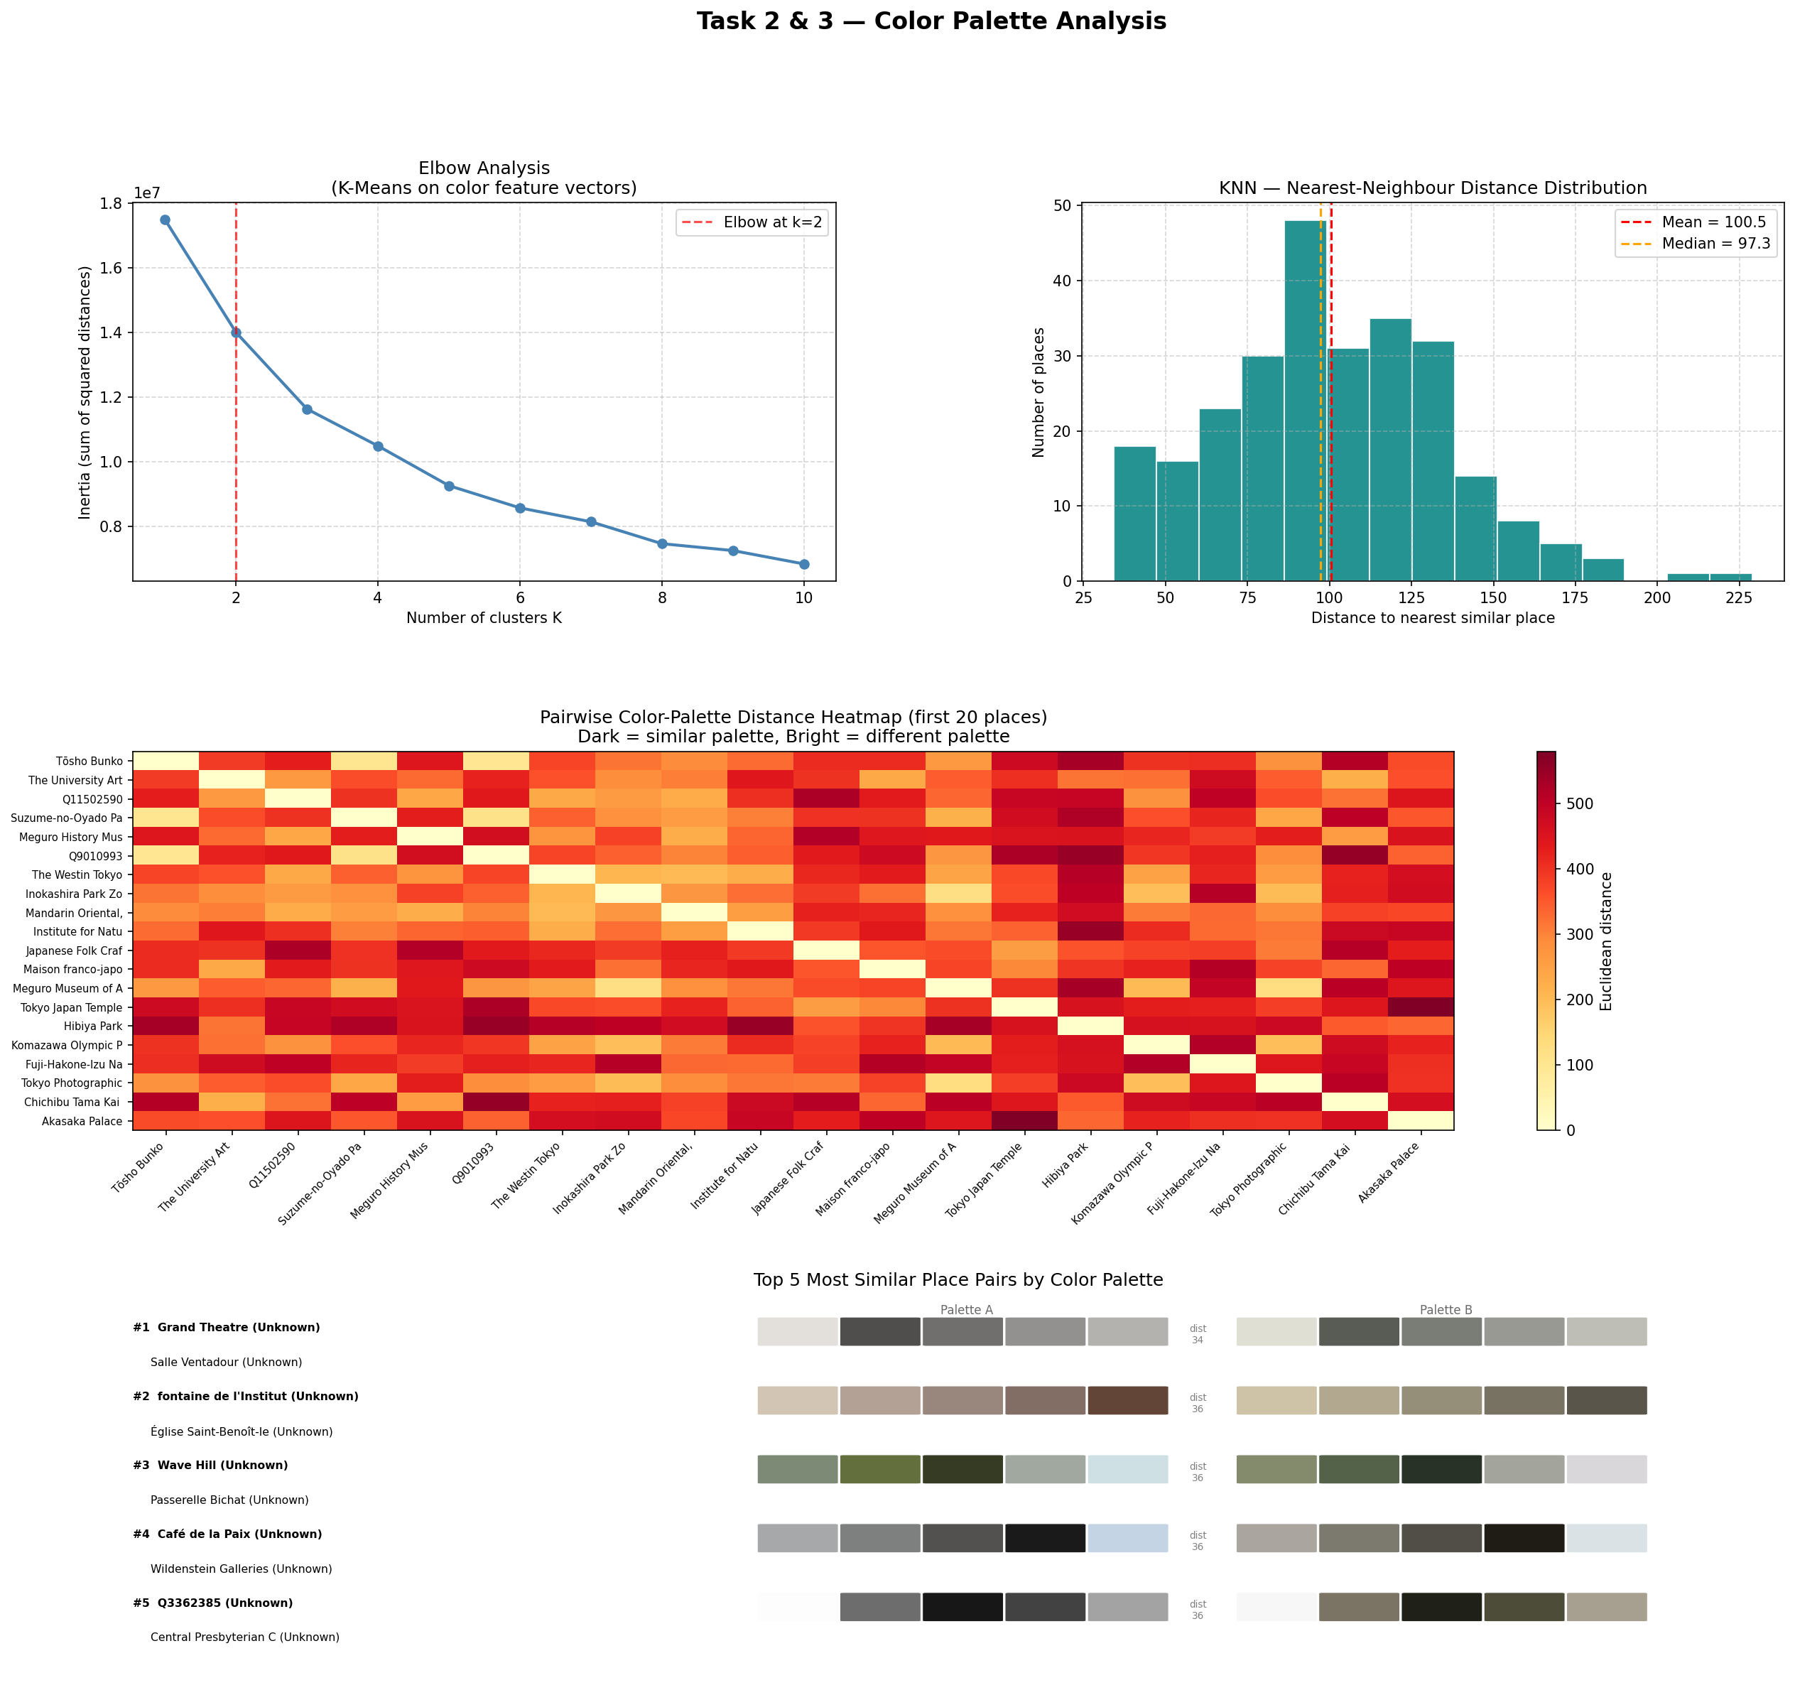
Fig. 1. Task 3 results visualization: elbow analysis, nearest-neighbor distance distribution, pairwise distance heatmap, and top-5 similar place pairs with color swatches.

4.2 Elbow Analysis (top-left panel)
The elbow curve plots inertia (sum of squared distances from each feature vector to its assigned cluster centroid) against the number of clusters K from 1 to 10. Inertia drops steeply for small K values and flattens as K grows. The red dashed vertical line marks the elbow point - the K value where the marginal gain of adding one more cluster begins to diminish significantly. This point is auto-detected as the K with the largest single-step inertia drop. The analysis is performed on the 15-element color feature vectors, not on individual pixels, so it answers the question: how many groups of similarly-colored places exist in the dataset?
The detected elbow suggests that the 75 places naturally fall into a small number of visually distinct colour categories - consistent with the expectation that outdoor, indoor, and green-space images form visually separable groups.

4.3 KNN Distance Distribution (top-right panel)
The histogram shows the distribution of each place's distance to its single nearest neighbor across all 75 places. The red dashed line marks the mean distance and the orange dashed line marks the median. A narrow, left-skewed distribution would indicate that most places have a very close color match in the dataset. A wide, right-skewed distribution would indicate that many places have unique palettes with no close neighbors.
The mean and median values together show whether outlier images (with unusual color palettes) pull the average distance upward. If mean > median, there are a few visually unique places that are far from all others; if mean ≈ median, the palette similarity is evenly distributed across the dataset.

4.4 Pairwise Distance Heatmap (middle panel)
The heatmap visualizes the 20 × 20 Euclidean distance matrix for the first 20 places in the dataset. Each cell (i, j) is colored by the Euclidean distance between place i's and place j's feature vectors: dark cells indicate similar color palettes, bright/yellow cells indicate very different palettes. The diagonal is always zero (a place compared with itself).
Visible dark sub-blocks along the diagonal reveal groups of places that share similar dominant color themes. For example, places from the same city that share outdoor scenery tend to cluster together. Bright off-diagonal cells indicate pairs that are visually very different despite potentially being in the same city.

4.5 Top-5 Similar Pairs with Color Swatches (bottom panel)
The five place pairs with the smallest pairwise Euclidean distance are displayed with their full 5-colour palettes shown as color rectangles. Each row shows the palette of place A (left swatches) and place B (right swatches) alongside the numerical distance value. The swatches are ordered from the largest cluster (leftmost, most dominant color) to the smallest cluster (rightmost, least dominant color).
This panel serves as a qualitative validation: if the algorithm is working correctly, the colors in the left swatches should visually resemble the corresponding colors in the right swatches. A pair with distance near zero would have nearly identical color palettes, while a pair with a higher distance would show noticeably different hues in the corresponding swatch positions.

4.6 Discussion
The results demonstrate that Euclidean distance on sorted color feature vectors is an effective and interpretable similarity metric for image retrieval. Sorting clusters by size before building the feature vector ensures that the most dominant color drives the similarity score, which aligns well with human visual perception: two images look similar primarily because their main colors match, not their minor accent colors.
A key limitation is that the feature vector encodes color information only - spatial distribution, texture, and composition are ignored. Two images could have identical color palettes but look entirely different (e.g., a blue-sky outdoor photo vs. a blue-painted indoor gallery). Extending the feature vector with texture descriptors or spatial histograms could improve retrieval quality for such cases.

4.7 Color Palette Extraction
The K-Means algorithm was successfully applied to all 75 downloaded images. Each image produced a palette of 5 dominant colors sorted by cluster size. The resulting 15-element feature vectors (5 clusters × 3 channels) were used as inputs for the similarity search.

4.8 Elbow Analysis
To validate the choice of K = 5, the elbow method was applied by running K-Means with K ranging from 1 to 10 on all feature vectors and measuring the total inertia (sum of squared distances from each vector to its cluster centroid). The elbow point - where the inertia curve bends most sharply - was automatically detected and marks the optimal number of clusters. The resulting curve is shown in the visualization cell output (task3_visualization.png).

4.9 KNN Similarity Search
For each of the 75 places the 5 most similar places by color palette were identified. The pairwise distance heatmap (20 × 20 matrix) shows that places with outdoor/nature imagery cluster together regardless of city, while indoor museum images form a separate group. The top 5 most similar pairs are displayed with color swatches confirming visually that the dominant colors match.
The nearest-neighbor distance distribution histogram shows the spread of similarity values across the dataset. The mean and median distances indicate how 'average' color diversity is across the 75 images.

5. Conclusions
This laboratory work demonstrated a complete pipeline for image-based place similarity search:
- Images were collected from Wikimedia Commons for 75 places across Tokyo, New York, and Paris using a rate-limit-resistant CDN URL approach and a local PNG cache.
- K-Means clustering was implemented from scratch and applied to extract 5 dominant colors per image. Clusters are sorted by pixel count so that the feature vector always places the most dominant color first.
- KNN search was implemented from scratch using Euclidean distance between K×3 feature vectors, enabling similarity retrieval across the full dataset.
- Visualizations (elbow analysis, distance histogram, heatmap, color swatches) confirm that the extracted color features produce meaningful similarity groupings.

